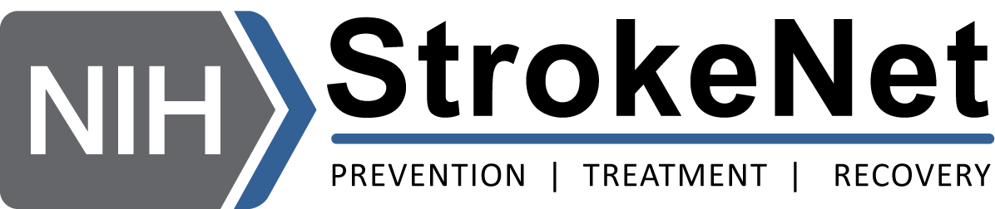

NIH StrokeNet Professional Development Webinar Schedule
All Times are Eastern Time
2024 – 2025
Date | Topic | Speaker | Time | Institution | Moderator
Aug 19 | Grant Writing | Dan Woo, MD | 12 Noon | University of Cincinnati | Farhaan, Vahidy, PhD, MBBS
Sept 4 | Tips for a Successful Scientific Presentation | Enrique Leira, MD | 1 PM | University of Iowa | Cemal Sozener, MD
Oct 10 | Mentoring | Devin Brown, MD | 4 PM | University of Michigan | Tatjana Rundek, MD
Nov 4 | Statistical Analysis – Collaborating with Data Mgt & Statistical Teams – Experts in Research | Jordan Elm, PhD | 12 Noon | MUSC | Devin Brown, MD
 | Trainee Presentations - TBA
 | Trainee Presentations - TBA
 | Trainee Presentations - TBA
 | Trainee Presentations - TBA
 | Trainee Presentations - TBA
 | Trainee Presentations - TBA
 | Trainee Presentations - TBA

